Parent Newsletter
ONE Forest School
at
Deerhead Nature Preserve
Weekly Focus of Interest
December

Workshop Series

Our workshop series will put our new basic tool skills to good use as we create different crafts from the natural supplies found in the forest!

Tool Use
*While some parents may have a few initial concerns regarding the tools we’ll be introducing to the children, don’t worry! Children can start using saws and knives as soon as they’re ‘able’. The ability to use a certain tool isn’t necessarily related to age but rather to the development of motor skills, the capacity to focus and listen to instructions, and the strength to grip the tool and exert sufficient force. Our preconceptions about whether a child is ready or not can be overturned when we see what they can do when given the chance.
During the next nine months we will be practicing and using the following tools:
- Bow Saw
- Hack Saw
- Pruning Saw
- Secateurs
- Palm Drill
- Hand Drill (egg-beater drill)
- Drilling Jig
- Sloyd Knife
- Scout Knife
- Companion Knife
*All children will be heavily supervised during all activities with any tools or knives.

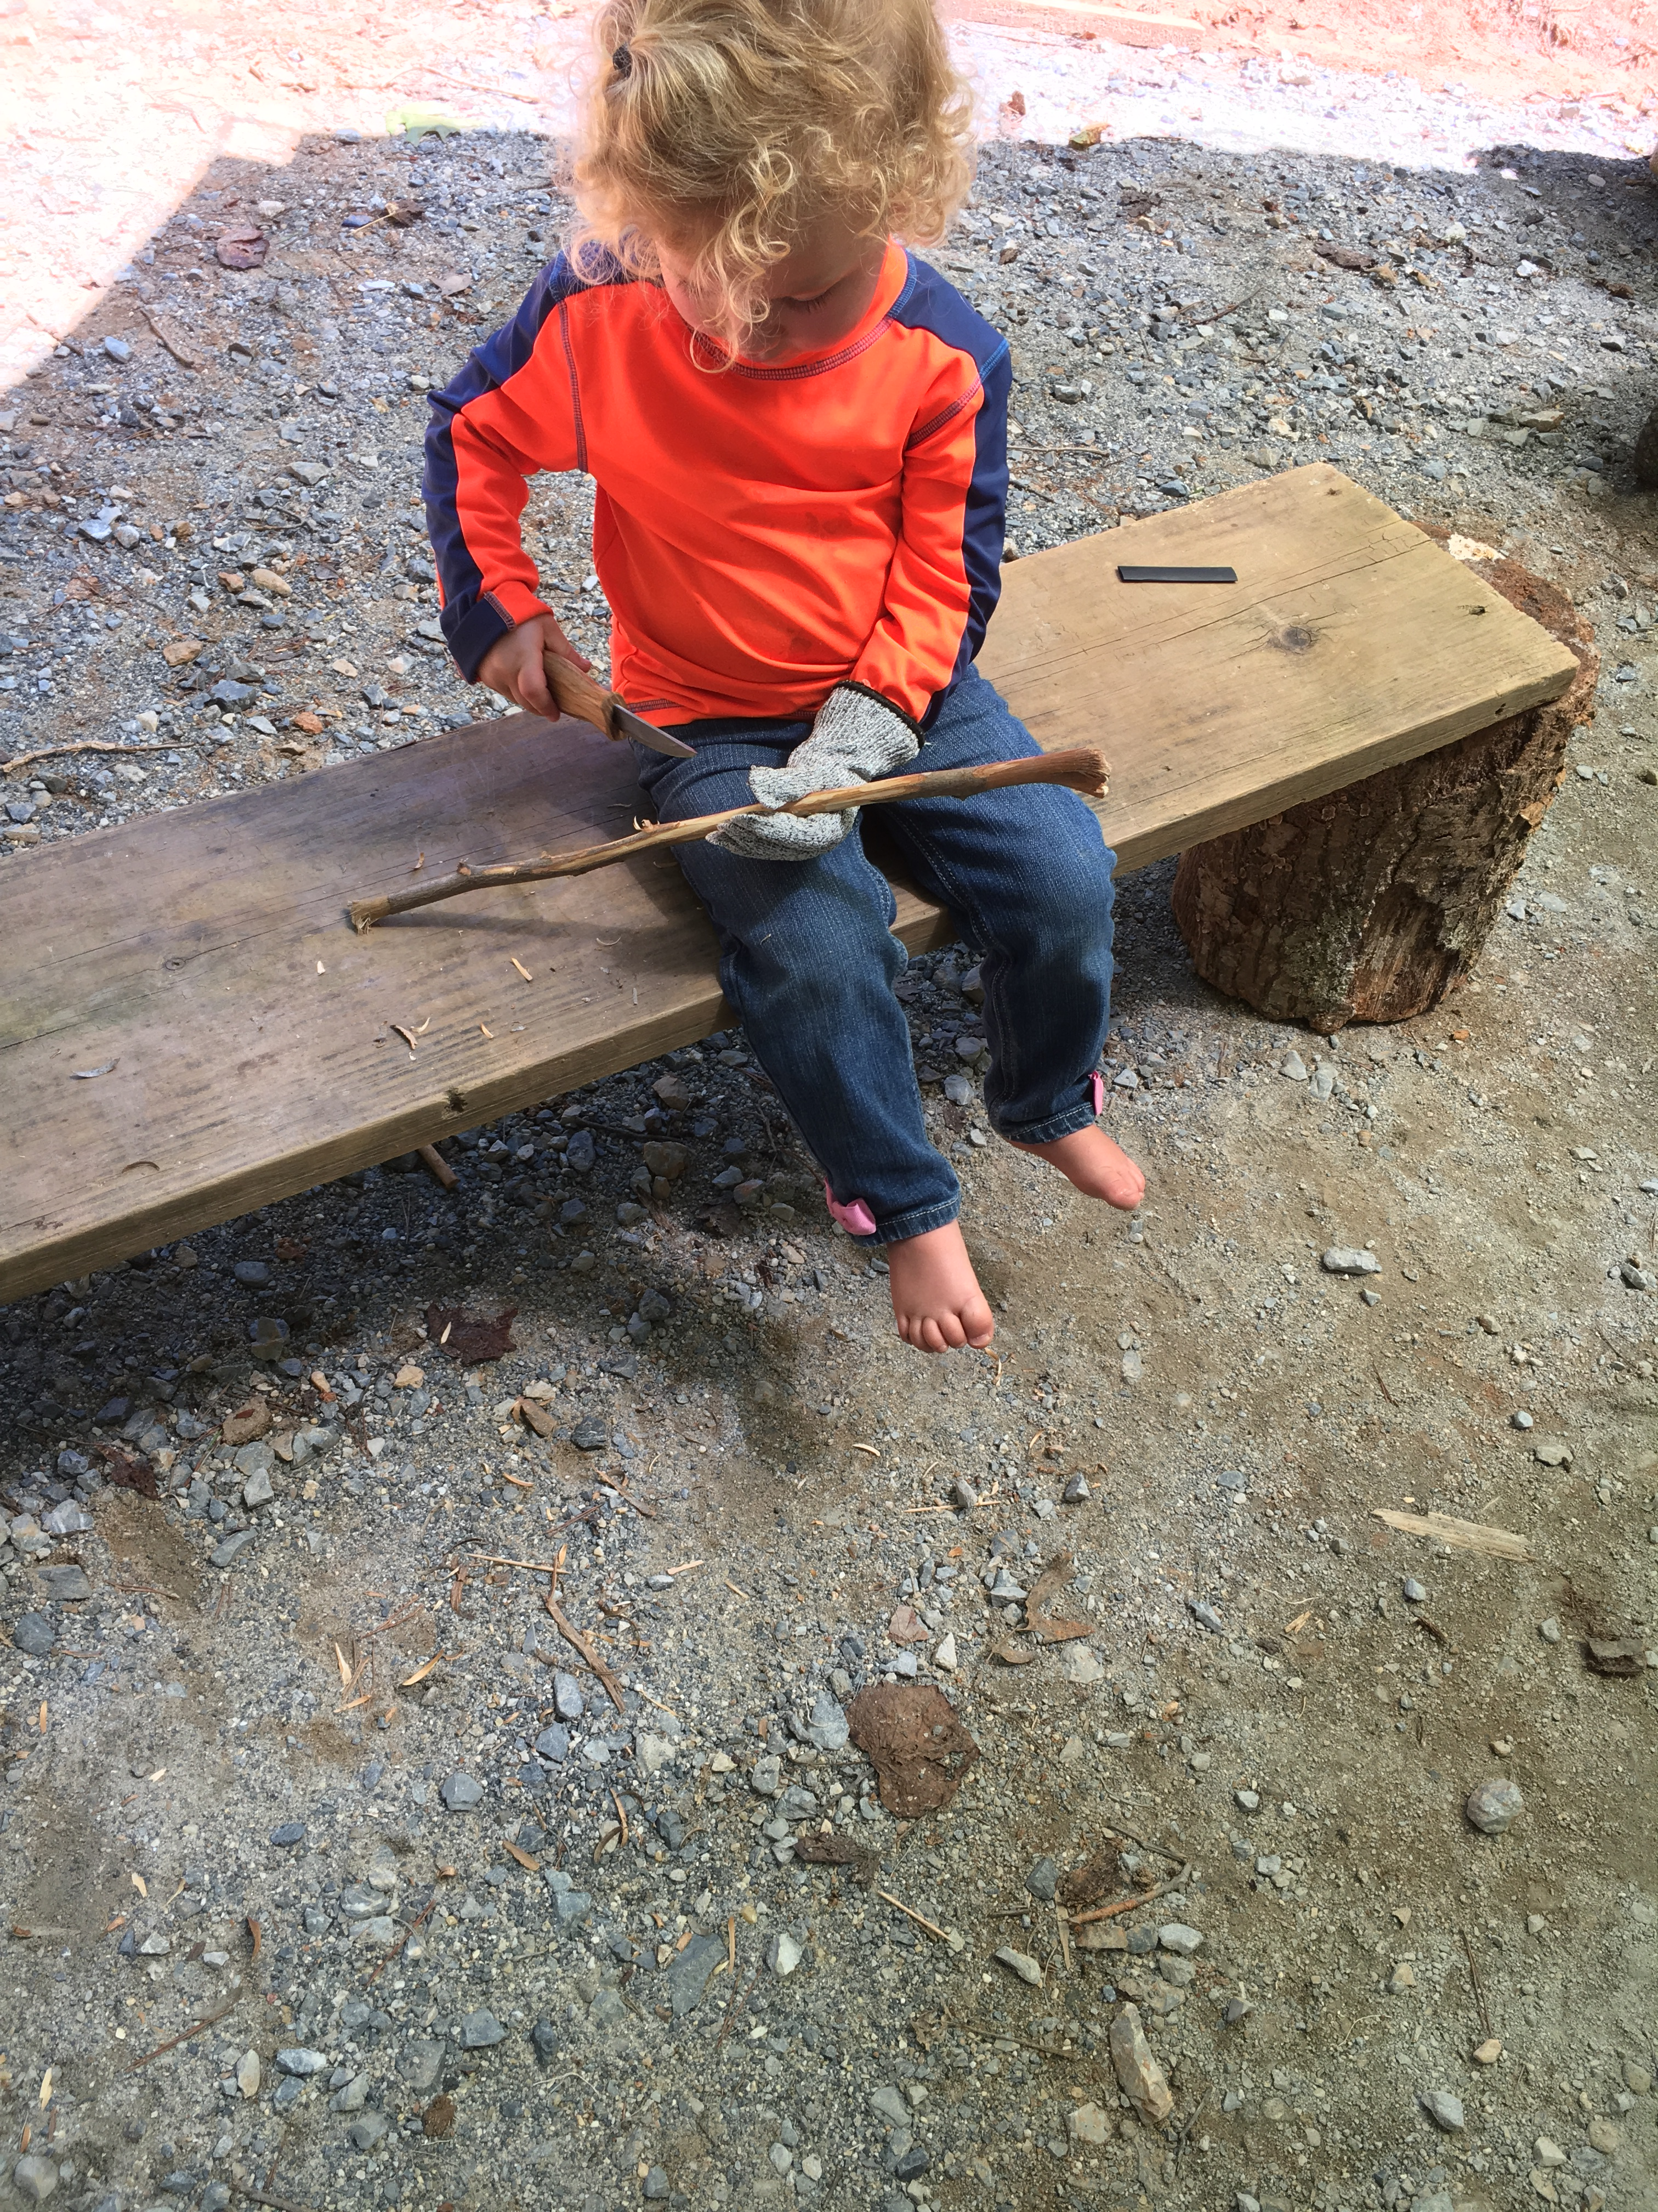
The month of December

- Forest School

Bedford County Schools will be out for their Winter Break December 23rd thru January3rd. ONE Forest School has been continuing its transition into a more formal and traditional style of Forest School learning by offering our Workshop Series. Children are learning forest-based crafting and improving their skills with basic tools. We still have our creek time/free play time but are more focused on the educational side of a learner-led approach to our projects. We’ve been practicing with hand drills, bow saws, using a vise, etc. to get ready for December! It is our introductory month for using these tools for crafting useful items to be used in the forest.

We’re still continuing our whittling sessions as the children really love this special activity. Whittling in the woods around a campfire is one of the best ways to enrich the physical, social, emotional, creative, and spiritual aspects of children’s lives.

Our journey with tree identification is moving along very smoothly! We’ve chosen the hickory tree to represent the month of December. The children really love finding and tasting the meat of the hickory nuts! To help us with identifying these trees, we will become familiar with its look, feel, smell and behavior and taste. Each of these identifiers, as well as behavior, can really only be gained by sawing, splitting and carving the wood from the tree. We will also be practicing our coppicing skills to ensure that the trees in our forest remain sustainable.

You, as parents, can help us help your children! If you have any of the tools we have listed, we never turn down donations!

A Month in Review:

November Highlights!

- Tree Cookies Art – Nut Necklaces!
- Tree Climbing – An unexpected lesson in tenacity
- Exploring musical sounds using untraditional methods
- Playing in the leaves
- Rainy Day Fun – Playing in the rain!
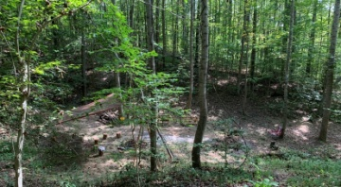
- Noticing Nature- Fall colors

- Where did all the frogs and turtles go?

